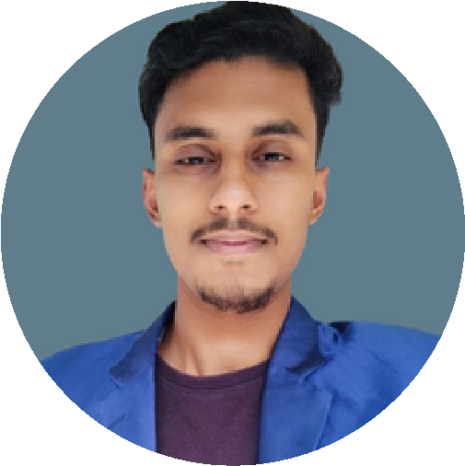

# CONTACT

01308390856

didarhossainemon.bd@gmail.com mirpur 10

***in*** https://www.linkedin.com/in/md-didar-hossain-14009a334utm_source=share&utm_campaign=share_via&ut?

m_content=profile&utm_medium=android_app

# TECHNICAL SKILL

Design Software: AutoCAD,

3ds Max, Lumion, Adobe

Photoshop

Rendering Skills: Post-

Processing, Layered

Compositions Office Tools: MS Office Suite

# SOFT SKILLS

Communication (Verbal and

Non-Verbal)

Critical Thinking and Problem

Solving

Emotional Intelligence and Empathy

Active Listening and Team

Collaboration

Leadership and Self-Motivation

# LANGUAGES

English (Basic)

Bangla (Fluent)

# DIDAR HOSSAIN

JUNIOR ARCHITECT

## PROFILE

I'm an architect and interior designer specializing in AutoCAD, 3ds Max, and Lumion. Skilled in creating innovative and functional spaces with a focus on impactful designs. Actively seeking opportunities to contribute to creative and collaborative projects in architecture and interior design.

## EXPERIENCE

**INTERIOR BANGLADESH (JULY 2024-DEC 2024)**

JUNIOR ARCHITECT

Created 5 Arhitectural project

developed 2 design plans for residential project Acted as the main point of contact between the team and senior management

## PROJECT

Interior Site, Bashundhara Residential Area (1800 sqft): Designed and implemented functional layouts tailored to client needs, ensuring optimal space usage.

Construction Site, Mirpur-1 (1400 sqft): Supervised on-site execution, ensuring adherence to architectural plans.

## SOFTWARE AND TOOLS

autocad:proficient in drafting floor plans,layouts,coordina

ting drawing,annotation and plotting with block libraries 3ds max: skilled in 3d modeling.texturing ,rendering and lighting design for realistic presentations.

## EDUCATION

**2020-2021**

Habiganj polytechnic institute

Architechture and interior technology

3.10

## REFERENCE

**Jannatul nahar deepti MAHFUJUR RAHMAN**

Department head of Architecht Senior Architect at Interior Bangladesh Habiganj Polytechnic Institute **Phone:** 01837-037302

**Phone:** 01713-522732 **Email :** archrisath3719@gmail.com